AGENTIC AI
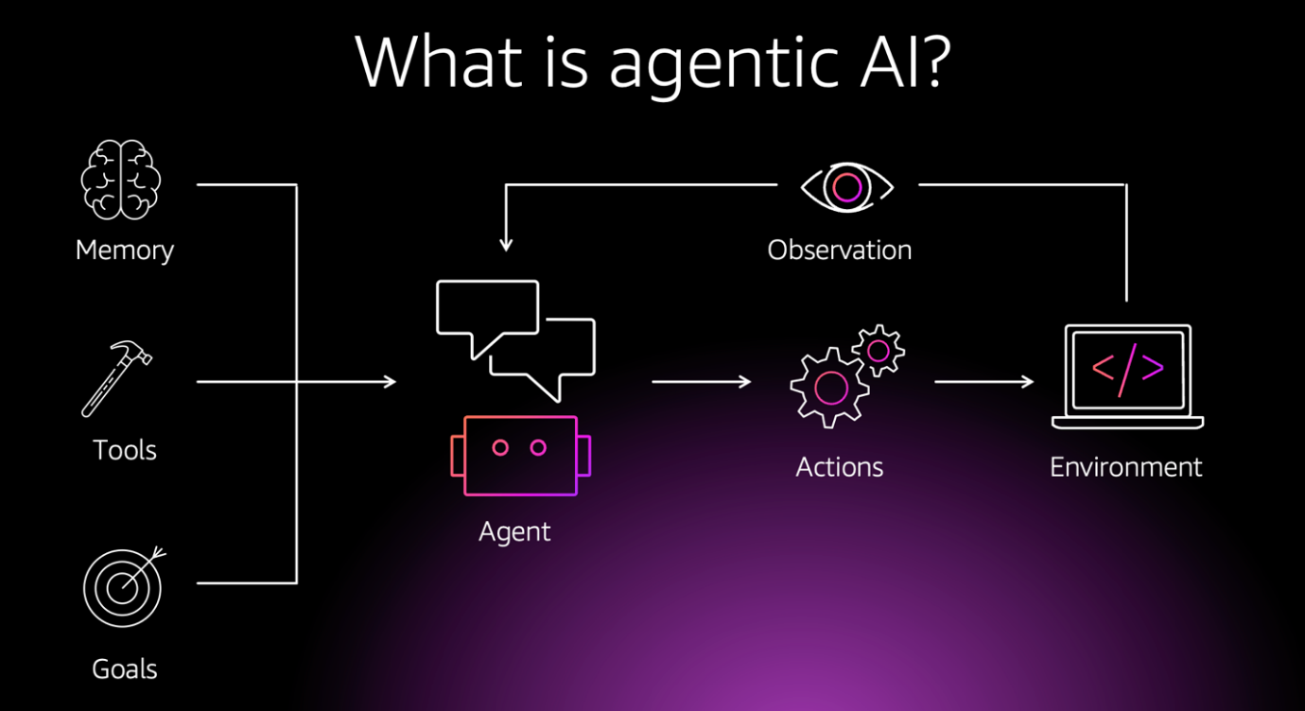

Definition: Agentic AI = AI systems that can make decisions, take actions, and pursue goals on their own, instead of just following direct instructions.

Agentic AI means an AI that doesn’t just answer questions or follow single commands. Instead, it can plan, decide what steps to take, and act toward a goal — almost like an assistant that works for you, not just with you.

- Decide → figure out what to do next.

- Act → actually take the step (send an email, run code, fetch info, etc.).

- Pursue goals → keep working toward an end result, not just a single command.

💡 Example:
- Normal AI:(non-agentic):
You say: “Book me a flight to Karachi on Friday.”
→ It just shows you a list of flights.

- Agentic AI:
You say: “Book me a flight to Karachi on Friday.”
→ It:
  - Searches available flights.
  - Compares prices, airlines, and times.
  - Checks your preferences (e.g., window seat, no long layovers).
  - Picks the best option.
  - Books it for you (using your payment info).
  - Sends you the ticket + adds it to your calendar.

So, in short → it’s AI with initiative, like a smart assistant that plans and acts, not just answers.

🔑 Key Abilities of Agentic AI
- Memory
  - Remembers past interactions, user preferences, and context.
  - Example: Knows you prefer evening flights and always pick a window seat.
- Planning
  - Breaks a big goal into smaller steps and figures out the order.
  - Example: To book a flight → search flights → compare options → book → send ticket.
- Reasoning
  - Can make choices, weigh pros/cons, and adapt if something changes.
  - Example: If Friday flights are too expensive, suggests Saturday as a cheaper option.
- Tool Use / Action
  - Uses external systems (APIs, websites, apps) to actually do stuff.
  - Example: Logs into an airline site, enters your details, and buys the ticket.
- Autonomy
  - Doesn’t wait for every little instruction; it can continue until the task is complete.
  - Example: After booking, it automatically sends you the boarding pass and updates your calendar.

That’s basically the “engine” behind agentic AI.

